Methods, Analysis, and Results

J. Ted Hillert

2023-08-12

# METHODS

### Study Site

Round bald is located in the Roan Mountain Massif of the Unaka Mountain range of the Southern Appalachian Mountains, between Carver’s Gap and Engine Gap. The Appalachian Trail (AT) bisects the study site into north and south sides of the trail. The site itself is spread across Pisgah National Forest in North Carolina and Cherokee National Forest in Tennessee, at approximately 36° 06’N and 82° 60’W. In 2020, Stokes and Horton (2022) surveyed the balds of Carver’s Gap following a 30-year mowing management protocol from Hamel and Somers (1990) and Murdock (1986). They detailed the vegetation composition of the balds according to vegetation genera. In February 2022, a low-intensity ground fire burned roughly 9.7 hectares of aboveground vegetation and was extinguished before it could spread further. This provided an opportunity to examine the changes in vegetation composition following low-intensity ground fire over the following season in June of 2022.

### Field Methods

In this study I sampled the first four transects reestablished by Stokes and Horton (2022). I quantified vegetation to genera by functional types; *Rubus*, *Vaccinium*, *Rhododenron*, forb, grass, sedge, moss, rock, or bare ground. I measured the percent coverage of vegetation using a 1-m^2 PVC quadrat divided into 100 equal sized squares, following Stokes and Horton (2022). Each square was visually assigned by dominant vegetation genera to equal 100% coverage per plot of aboveground vegetation up to 1-meter in height. Using the data collection sheet from Stokes and Horton (2022) and USFS botanist Gary Kauffman - which quantifies vegetation based on focal genera - a total of 226 plots along 12 transects were sampled in 2020, of these, 52 plots - along the first four transects were in the February 2022 fire - and another 47 plots - along the same transects - were unburned.

### Soil Seed Bank

To examine the effects of the fire on the soil seed bank, soil samples were collected in July 2022 and January 2023. In July 2022, approximately 200 grams of soil were obtained from the top 5 cm of soil at six random sites in one of four treatments; over 50% *Rubus*/burned, over 50% Rubus/unburned, under 25% Rubus/burned, under 25% Rubus/unburned. The first - over 50% Rubus/burned - describes plots with greater than 50% cover of blackberry and burned from the February 2020 fire, followed by greater than 50% blackberry and unburned, less than 25% blackberry and burned, lastly, less than 25% blackberry and unburned. A total of 24 soil seed banks samples were taken, placed in tins, transferred to the greenhouse, then sown in 28x22 cm seedling trays filled with potting mix to 5 cm depth. An additional six trays were filled with unaltered potting mix which acted as greenhouse controls to rule out contamination. Trays were then randomly set in the greenhouse at ambient temperature and humidity which was measured continuously with a Govee probe – that continuously measures temperature, percent relative humidity, dew point, and vapor-pressure-deficit. As seedlings emerged they were identified, recorded, and removed. The seedlings that could not be identified were re-potted until identifiable following Price et al. (2010). Each month the trays were rotated in random order to rule out growth condition bias. In December of 2022, the soil sample trays were placed outside to simulate winter conditions and potentially germinate seeds in the seed bank over the next spring. A second soil seed bank germination trial following the same protocol was conducted in mid-to-late March 2023 to July 2023. These samples will examine what is readily germinable following natural winter weathering and will be compared to the first seed bank set to examine post burn germinable seeds versus post winter germinable seeds.

A modified soil extraction method from the second soil sample was added in 2023 following Price et al. (2010); Abella et al. (2013); and Chiquoine and Abella (2018). These authors identify that both methods – seed extraction and seed germination – can provide insight into the potential vegetation community, but a combination of the two provides a more robust estimate of the state of the seed bank. A second set of soil seed bank samples were collected in January of 2023 following the same protocol as the first set. This time, however, two samples were taken from each plot and a total of 76 samples were collected from 36 sites on Round bald. One half of these samples were dried, weighed, and underwent seedling extraction. The second set of soil seedbank samples were collected in January 2023 and set in the fridge at 4 °C until March 2023. In March samples were removed from the fridge and set in the greenhouse to thaw and dry. After which each sample was sifted through 4000-micron mesh and then sifted through with jeweler’s forceps to locate and count seeds - a total of 34 samples underwent seed extraction. Another 36 samples were placed in one half of 10x20 inch seedling trays divided down the center, such that each sample was in a 10x10 inch area. To accommodate for space in the greenhouse a total of 15 burned, 15 unburned, and 6 controls samples were sown into eighteen 10x20 inch seedling trays such that one half contained a sample that was burned and the other half had a sample that was unburned.

# Analysis

Differences between the 2020 and 2022 plant community were analyzed using percent covers of vegetation and seedling emergence data. The initial question was to discover whether species percent covers were different between plots that were burned and plots were unburned. Multi-response permutation procedure (MRPP) is a non-parametric test to describe difference between groups based on a chosen distance function (McCune and Medfford 2011). Sorensen’s distance was calculated from the percent cover data. Categorical variables were removed from the data matrix and analysis was performed on a matrix of 198 plots by 10 species. The T score produced by MRPP indicates the degree of difference between groups, while the A-value is the effect size within groups, and a p-value to establish the level of test significance. Dominance curves were also used to examine the distribution of vegetation by percent cover between years. Another look at the distribution of the data was conducted using ordination of vegetation plots. Ordination was conducted in PCORD 6 (McCune and Medfford 2011) to examine the multivariate percent covers of vegetation data. Nonmetric Multidimensional Scaling (NMDS) is used to visualize the data by arranging plots in two-dimensional ordination space. This method is used to represent similarity values calculated from species percent cover data. NMDS is a non-parametric test well suited for multivariate percent covers using a predetermined distance metric. A NMDS plot ordination was created for unburned and burned vegetation data between 2020 and 2022.

Soil seedbank emergence data were combined into one dataset with zeros removed and examined using t-tests between burned and unburned plots of each vegetation type that grew from sample trays. Another t-test was used to compare vegetation between burned and unburned samples. Shannon diversity was run on soil samples emergence data to examine the diversity of species that grew from the seedbank in burned and unburned plots.. Shannon evenness was also used to compare the composition and richness of burned and unburned samples. Seedbank extraction was conducted on the 2023 sample set and averages per 100 grams were calculated.

# Results

Analysis of vegetation cover data by MRPP indicated significant variation between burned and unburned plots (p < 0.0001). Average distance for unburned plots equals 0.607, while the distance for burned plots was 0.475, indicating little difference between groups (T = -8.642). Dominance curves between 2020 and 2022 indicate a marked increase in *Rubus* and rock species and a marked decrease in Rhodo and forb species (Figure 1). NMDS analysis of burned and unburned data grouped them in much of the same space with most data points in the same space (Figure 2-3). Indicating little difference between burned and unburned vegetation plots. A handful of data points were outlying the major ordination space indicating a difference in vegetation in unburned data points in 2020 and 2022. Analysis of these outlying data points indicates greater relation of vegetation to bare rock, moss, and *Rhododendron* species (Figure 2).

Analysis of seedbank emergence data was conducted using t-tests on vegetation types *Rubus*, grass, and forb species. T-test scores for each were not significant - *Rubus* p-value = 0.5998, grass p-value = 0.7887, and forb p-value = 0.3758. Likewise, t-test score for all seedbank emergence data was insignificant (p-value = 0.6492), indicating little difference in vegetation growth between plots that were burned versus plots that were unburned. Shannon diversity scores indicate a different trend, the total diversity in the unburned samples was greater than the diversity in the burned samples, 1.051 versus 0.854 – respectively. Shannon’ evenness scores indicate similar evenness between unburned and burned samples, 0.758 versus 0.777 – respectively. Seed extraction data shows a greater number of seeds per 100 grams in burned samples versus unburned samples, 105.48 seeds/100g versus 26.73 seeds per 100g – respectively.

Figure 1. Dominance curves of vegetation abundances by percent cover between years, 2022 on top and 2020 on bottom.

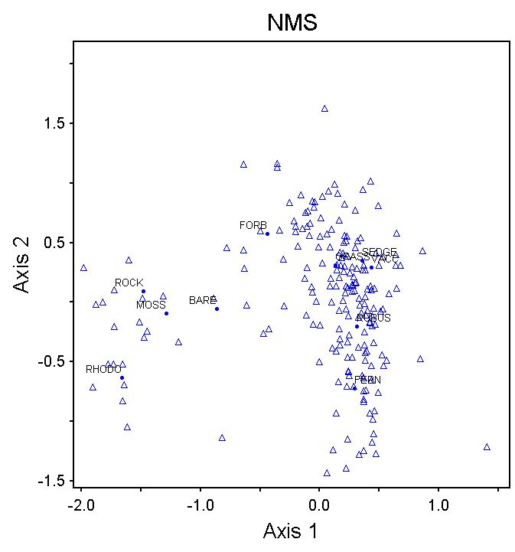

Figure 2. NMDS Ordination of vegetation plots in burned and unburned areas in 2020 and 2022. Data labels indicate the relation between vegetation type to vegetation plots.

Figure 3. NMDS ordination of vegetation plots with individually color-coded plots. Red – 2020 burned, green – 2020 unburned, blue – 2022 burned, and purple – 2022 unburned.

Abella, S. R., L. P. Chiquoine, and C. H. Vanier. 2013. [Characterizing soil seed banks and relationships to plant communities](https://doi.org/10.1007/s11258-013-0200-3). Plant Ecology 214:703–715.

Chiquoine, L. P., and S. R. Abella. 2018. [Soil seed bank assay methods influence interpretation of non-native plant management](https://doi.org/10.1111/avsc.12393). Applied Vegetation Science 21:626–635.

Hamel, P., and P. Somers. 1990. Vegetation analysis report: Roan mountain grassy balds. Challenge Cost Share Project.:25.

McCune, B., and M. J. Medfford. 2011. [PC-ORD. Multivartiate analysis of ecological data. Version 7](https://www.wildblueberrymedia.net/software). MjM Software Design, Gleneden Beach, Oregon, USA.

Murdock, N. A. 1986. Evaluation of management techniques on a southern appalachian bald. Unpublished M.S. Thesis. Western Carolina University. 62 pp.

Price, J. N., B. R. Wright, C. L. Gross, and W. R. D. B. Whalley. 2010. [Comparison of seedling emergence and seed extraction techniques for estimating the composition of soil seed banks](https://doi.org/10.1111/j.2041-210X.2010.00011.x). Methods in Ecology and Evolution 1:151–157.

Stokes, C., and J. L. Horton. 2022. [Effects of grassy bald management on plant community composition within the roan mountain massif](https://doi.org/10.2179/0008-7475.87.1.105). Castanea 87:105–120.